**HEART DISEASE ANALYSIS**

**Define Problem/Problem Understanding**

**Define Problem Statement:** Visualizing and Predicting Heart Diseases with an Interactive Dashboard

**Business Requirements:** The health care industry produces a huge amount of data. This data is not always made use to the full extent and is often underutilized. Using this huge amount of data, a disease can be detected, predicted or even cured. The business requirements for analyzing the Heart Disease in world include identifying patterns and comparing factors of heart disease, creating interactive dashboards and reports, identifying areas for improvement, making data-driven decisions, comparing to the current situation and creating forecasting models for future performance. The ultimate goal is to gain insights and improve performance through data visualization techniques.

**Literature Survey:** A literature study is necessary for a project that uses an interactive dashboard to visualize and forecast heart illness. It covers pertinent studies on data visualization for heart disease, predictive modeling, interactive dashboard design, and user experience in healthcare applications. In order to guide the creation and use of a successful heart disease prediction dashboard, the survey attempts to uncover best practices, predictive models, visualization strategies, and ethical considerations from previous research and initiatives.

**Social or Business Impact:**

Social Impact: Analyzing heart disease has profound social impacts, ranging from individual-level health outcomes to community empowerment and public health initiatives. By promoting awareness, prevention, equitable healthcare access, and research advancements, heart disease analysis plays a crucial role in improving the well-being of individuals and society as a whole. Business Model/Impact: Analyzing heart disease has substantial business impacts across various sectors, including healthcare, medical technology, pharmaceuticals, digital health, insurance, research, workplace wellness, and consumer products. It creates market opportunities, drives innovation, and influences policy and advocacy efforts in the fight against heart disease.

**Data Collection and Extraction from Database**

**Downloading the Dataset:** Heart_new2 dataset is downloaded for making visualizations.

Column Description of the Dataset:

1. HeartDisease - target trait.

2. BMI – A value that allows you to assess the degree of correspondence between a person's mass and his height, and thereby indirectly judge whether the mass is insufficient, normal or excessive. It is important in determining the indications for the need for treatment.

3. Smoking: It is a major risk factor for cardiovascular disease. When smoke from a cigarette is inhaled, the reaction of the cardiovascular system immediately follows: within one minute, the heart rate begins to rise, increasing by 30% within ten minutes of smoking. The bad habit also increases blood pressure, fibrinogen and platelet levels, making blood clots more likely.

4. AlcoholDrinking - alcohol causes not only temporary disturbances in the functioning of the heart, but also permanent ones. Heart pain after alcohol is not the only health problem associated with alcohol consumption.

5. Stroke - Ischemic stroke occurs 4 times more often than hemorrhagic. One of the leading causes of this suffering is heart disease, which impairs its functioning, as a result of which the blood flow in the arteries is disturbed and the blood supply to the brain is reduced. Another cause of stroke in heart disease is thromboembolism, when clots form in the cavities of the heart (most often with heart failure) - blood clots.

6. PhysicalHealth - how many days in a month did you feel poor physical health.

7. MentalHealth - how many days in a month did you feel poor mental health.

8. DiffWalking - difficulty climbing stairs.

9. Sex - gender of a person.

10. AgeCategory - age category of the subjects.

11. Race- Race is a complex social construct that categorizes people into distinct groups based on certain physical and genetic characteristics

12. Diabetic – Person suffering from Diabetes

13. PhysicalActivity - adults who reported doing physical activity or exercise during the past 30 days other than their regular job

14. GenHealth - well-being.

15. SleepTime - number of hours of sleep.

16. Asthma- Asthma is a chronic respiratory condition due to breathing Issue

17. KidneyDisease – Disease related to Kidney

18. Skin Cancer – People suffering from Skin Cancer

**Storing Data in DB and Perform SQL Operations:**



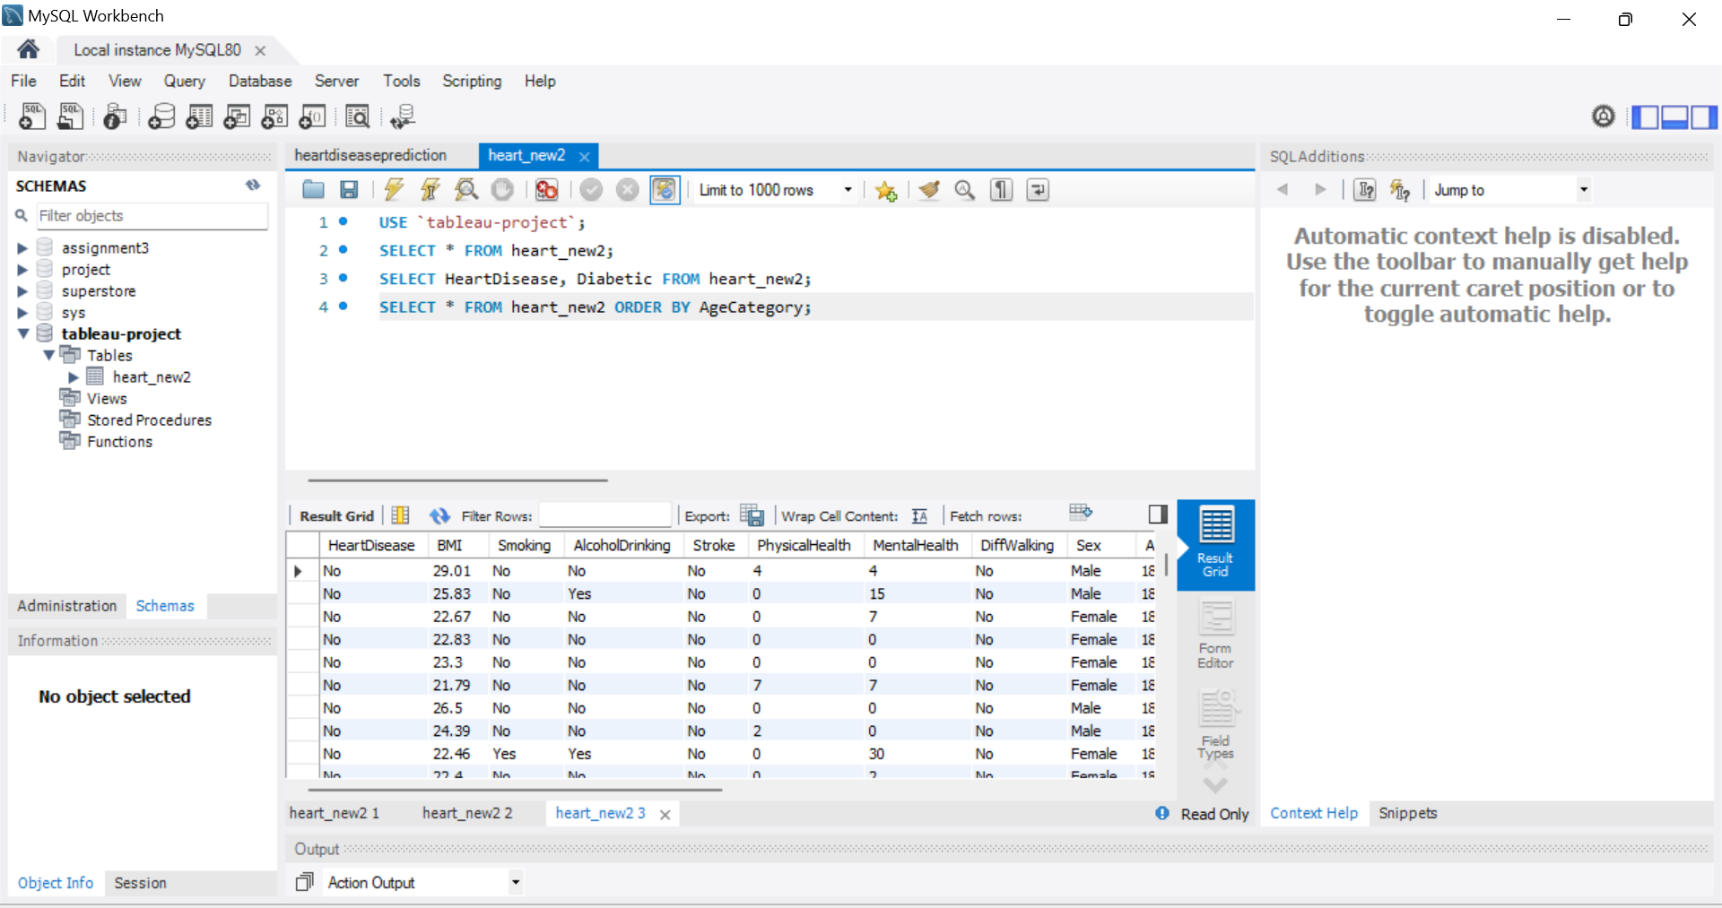

**Connect DB with Tableau:**

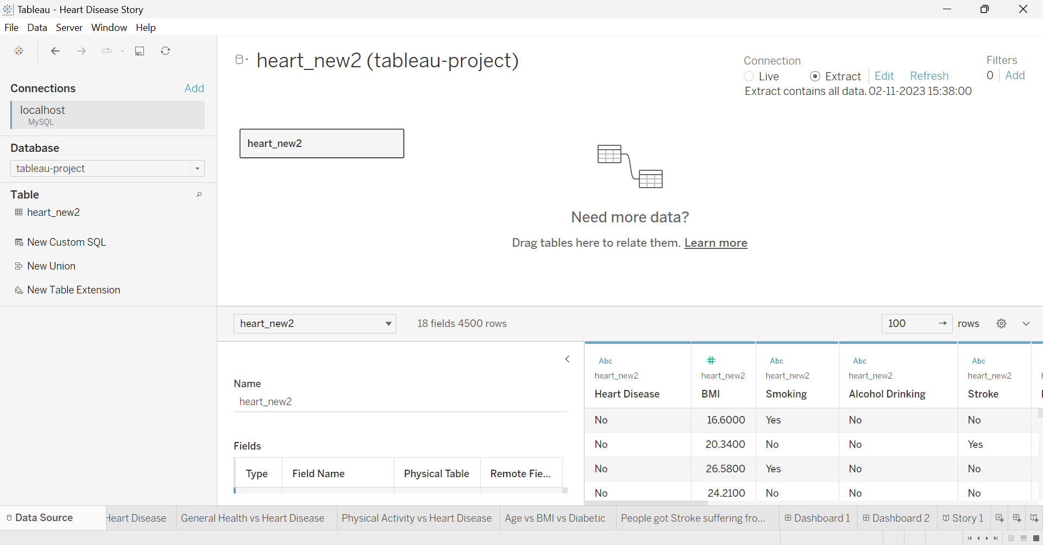

**Data Preparation**

**Prepare the Data for Visualization:** Preparing the data for visualization involves cleaning the data to remove irrelevant or missing data, transforming the data into a format that can be easily visualized, exploring the data to identify patterns and trends, filtering the data to focus on specific subsets of data, preparing the data for visualization software, and ensuring the data is accurate and complete. This process helps to make the data easily understandable and ready for creating visualizations to gain insights into the performance and efficiency. Since the data is already cleaned we can move to visualization.

**Data Visualization**

**No of Unique Visualizations:** There are 10 unique visualizations.

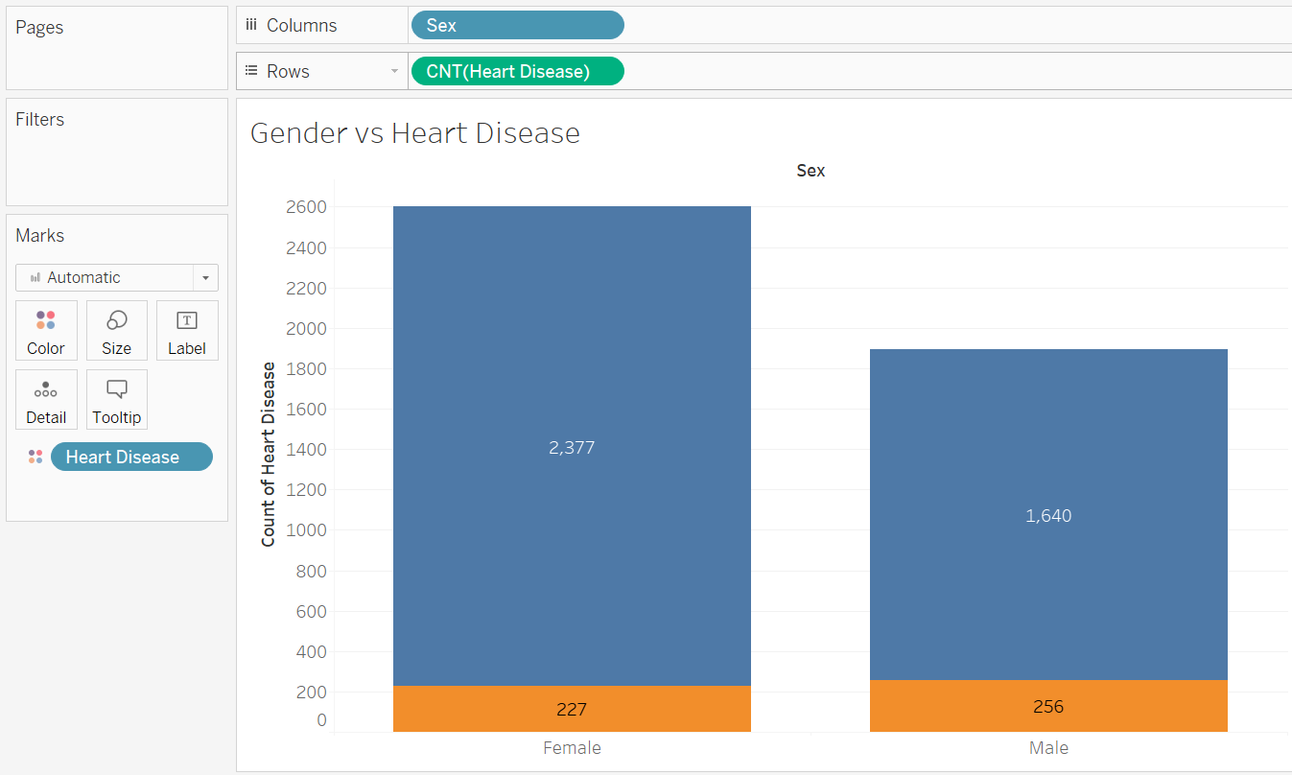

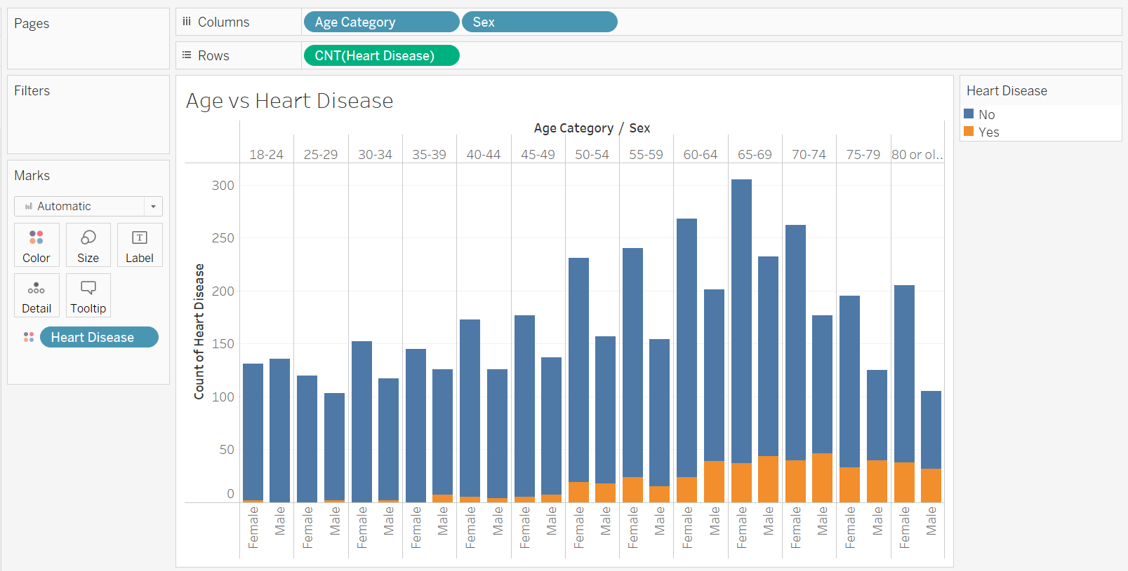

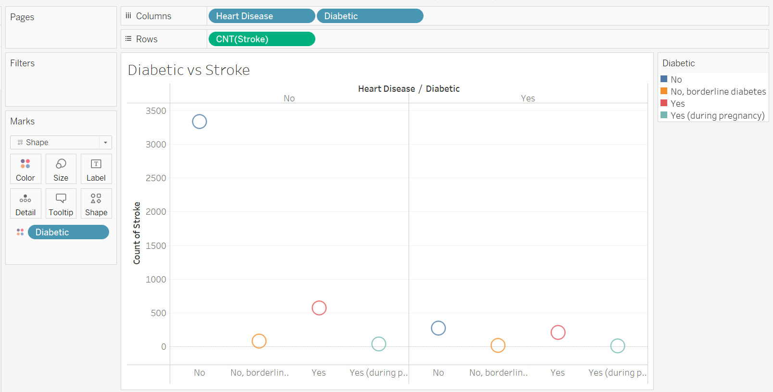

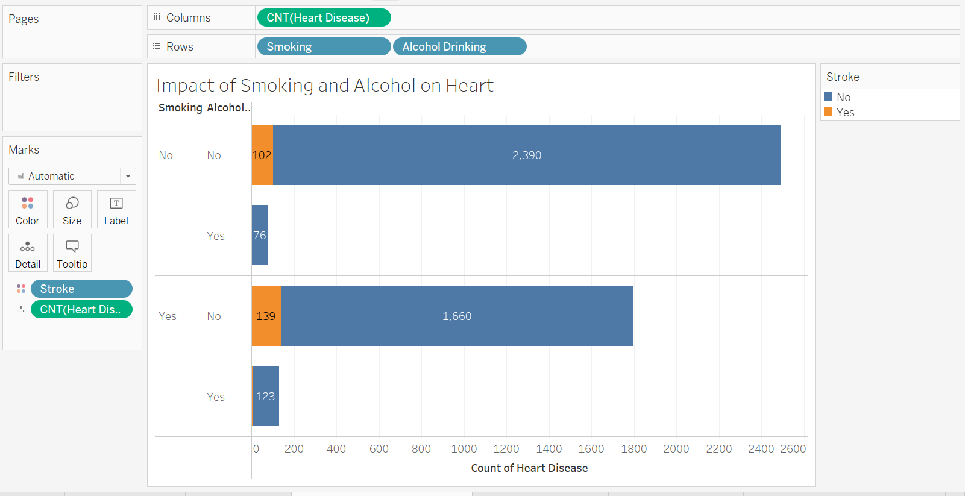

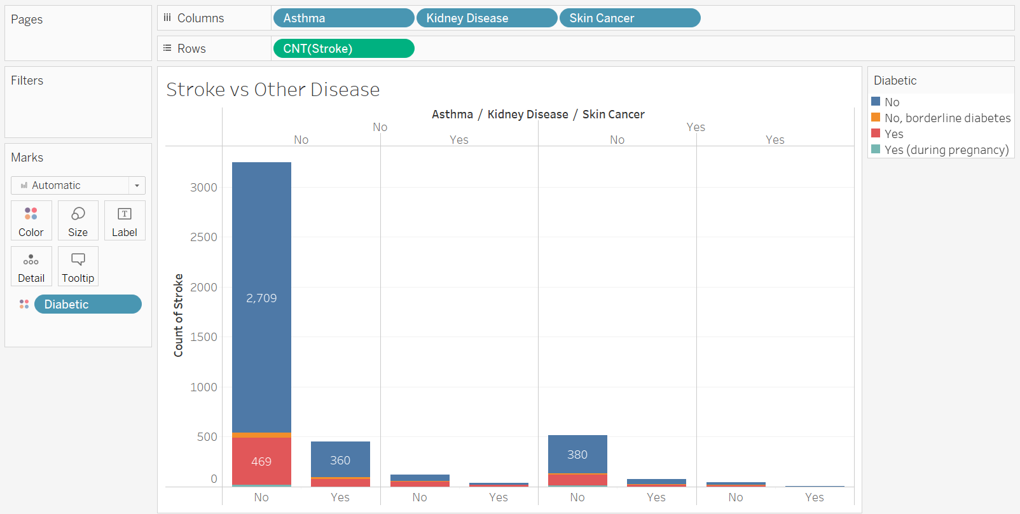

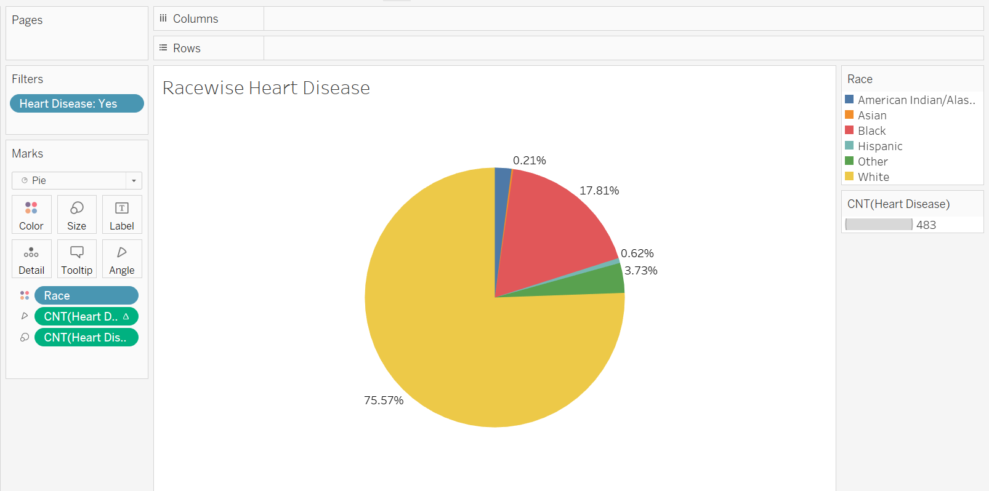

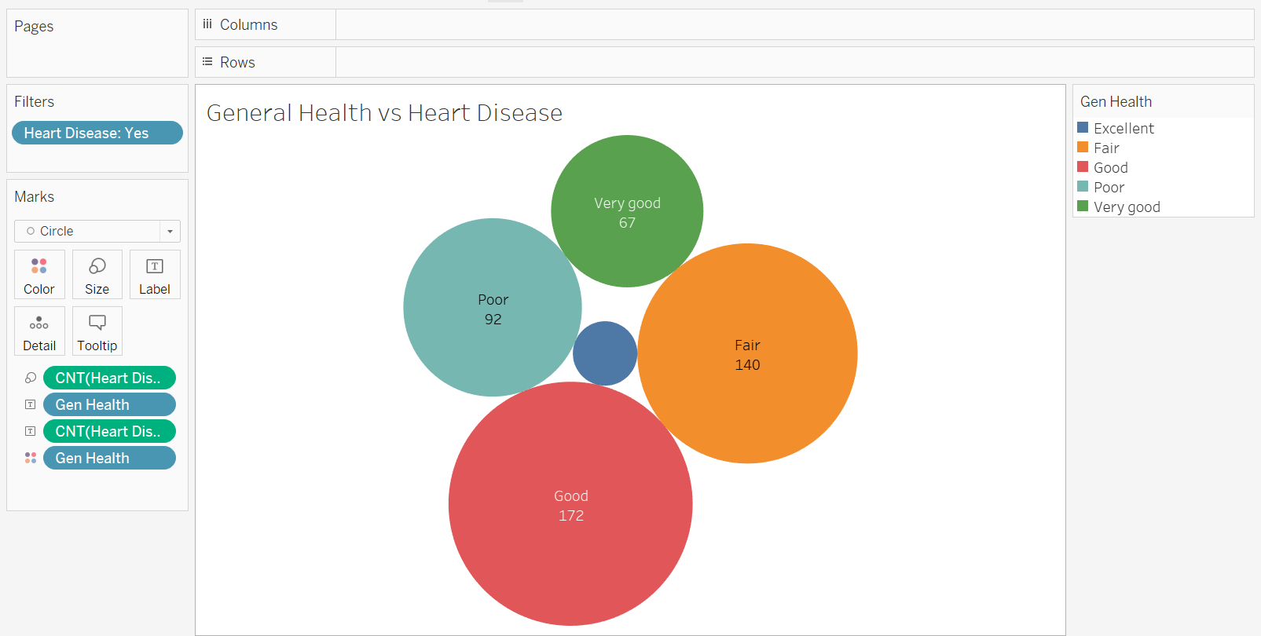

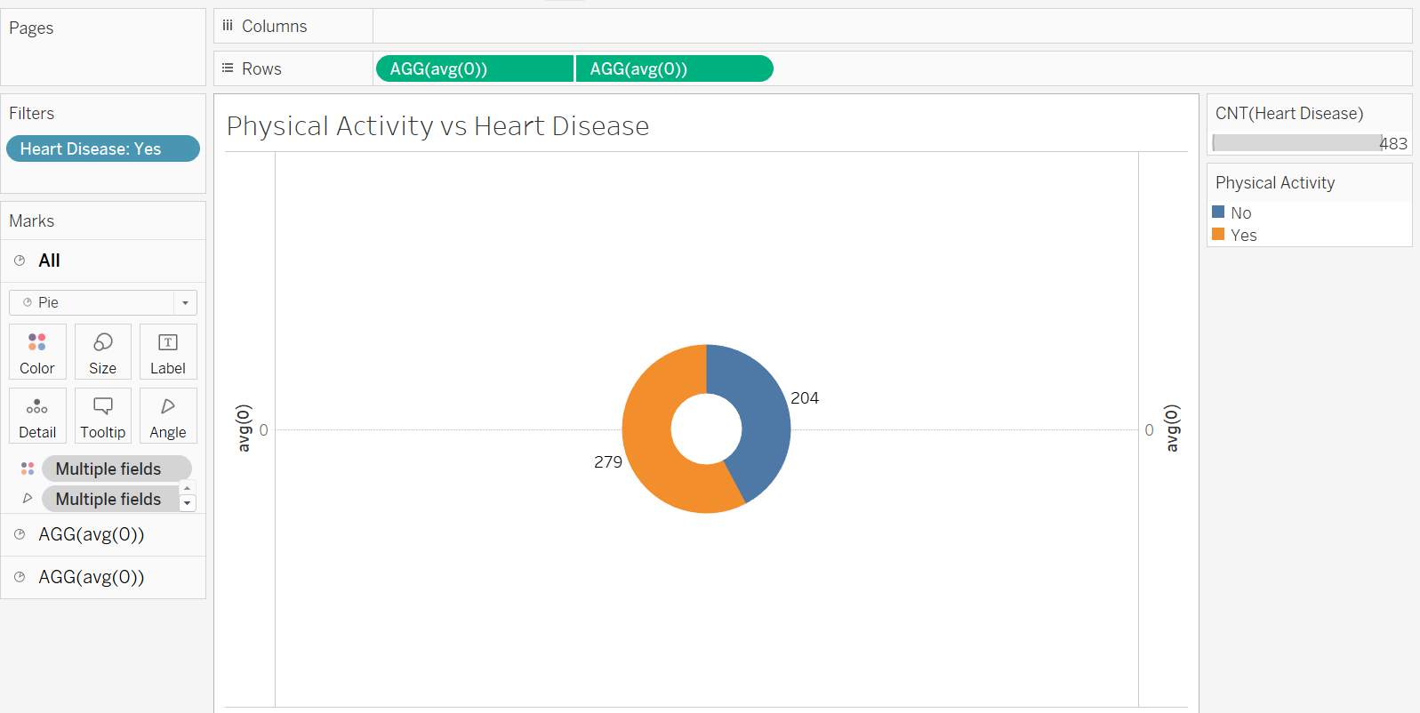

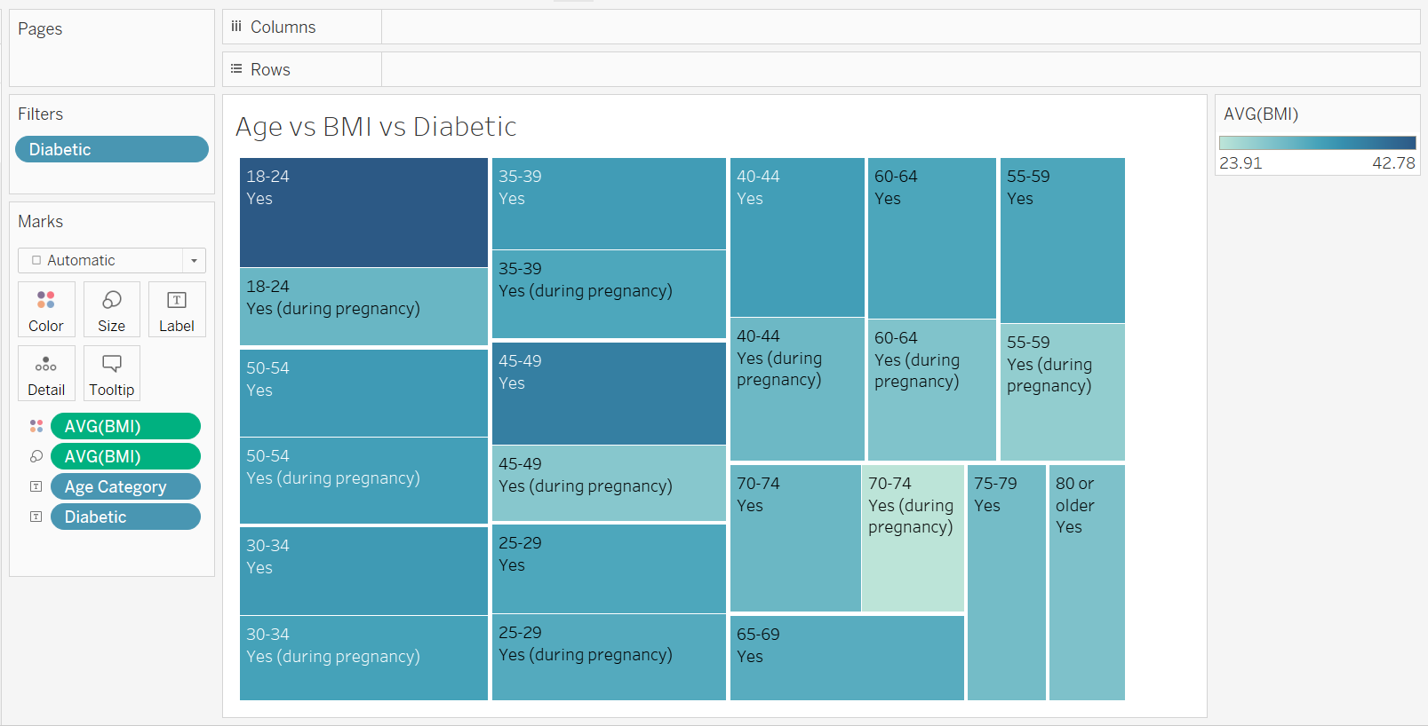

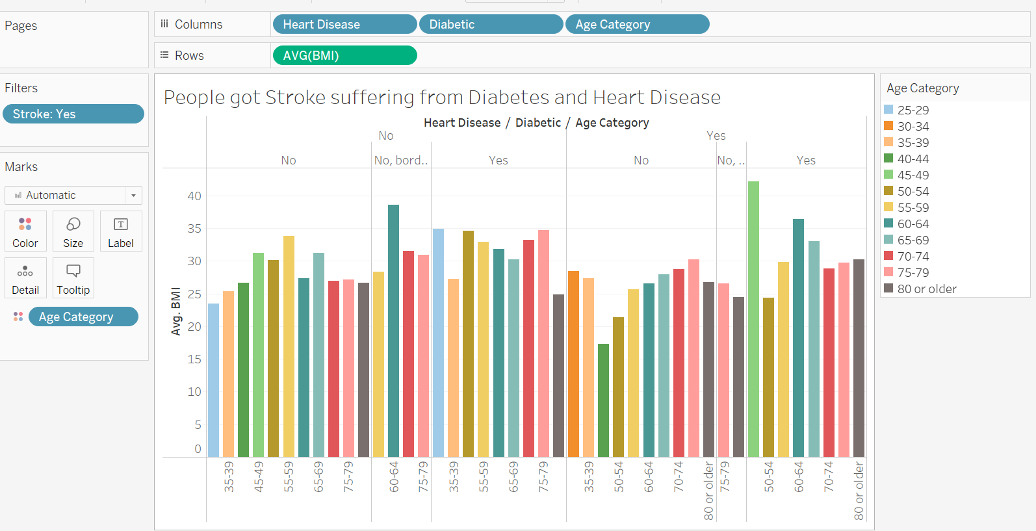

**Dashboard**

**Responsive and Design of Dashboard:**

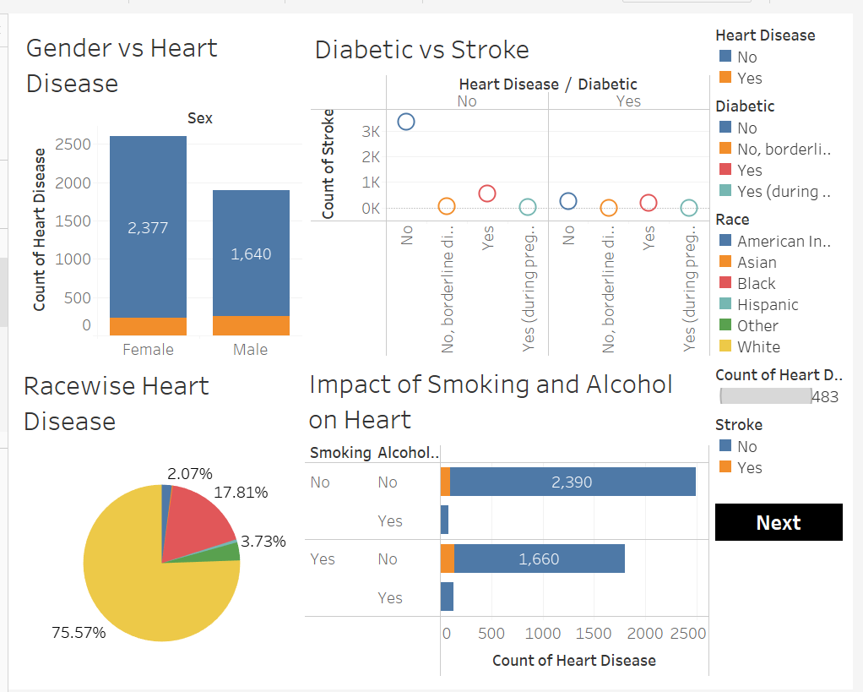

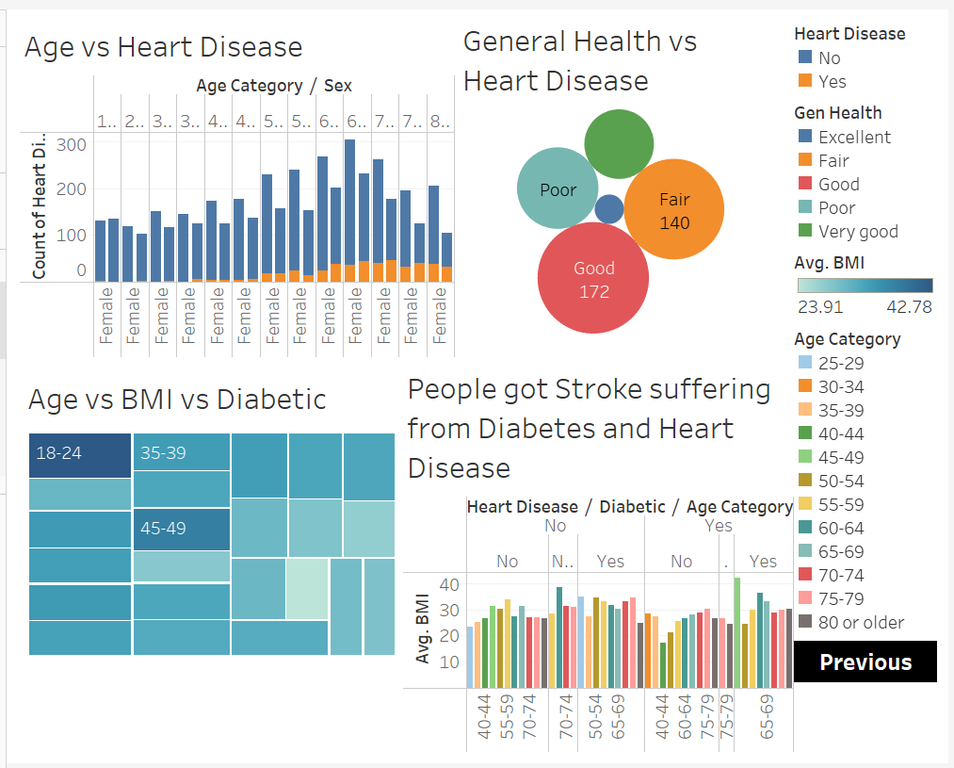

**Story**

**No of scenes of Story:** Total 8 unique scenes of story.

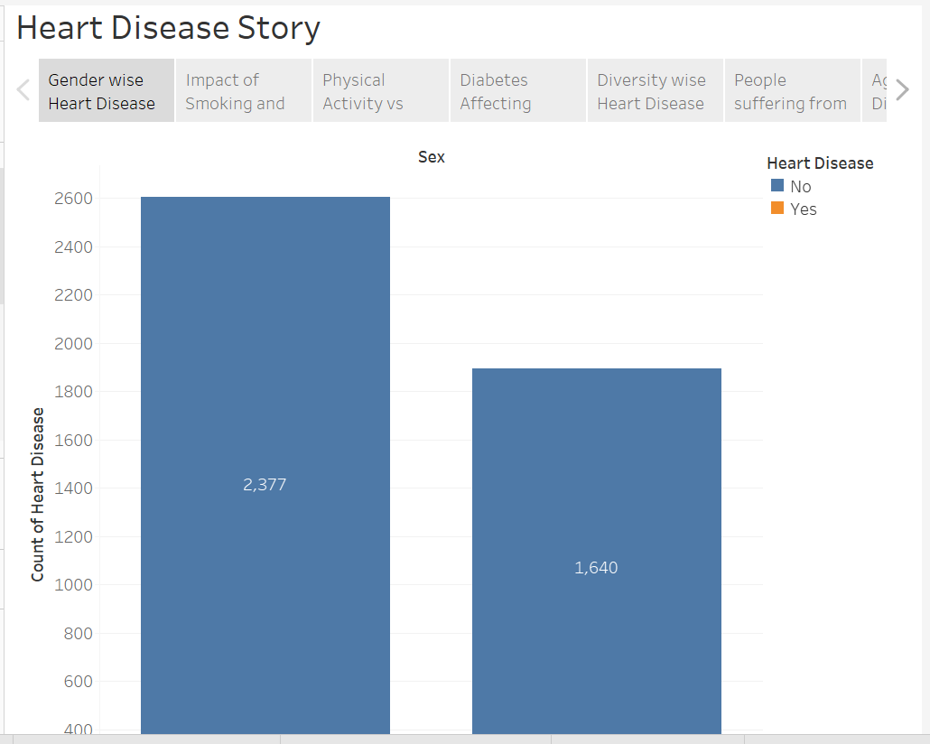

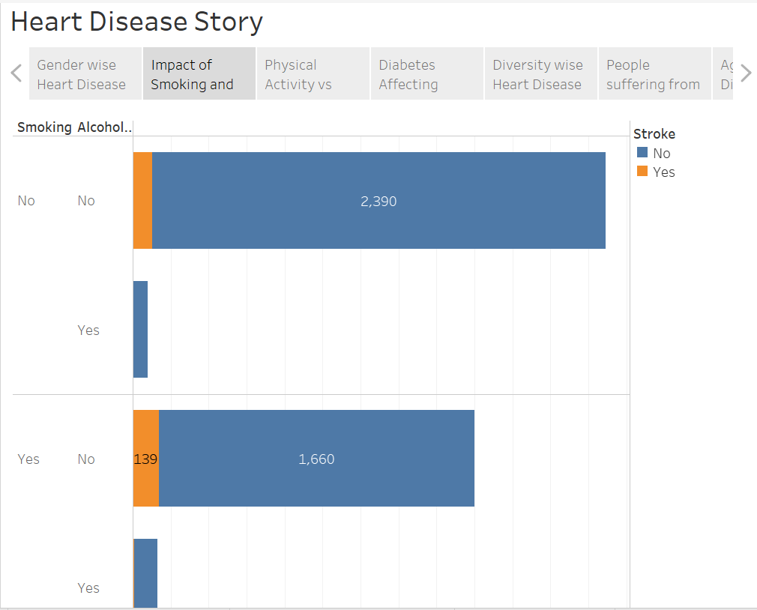

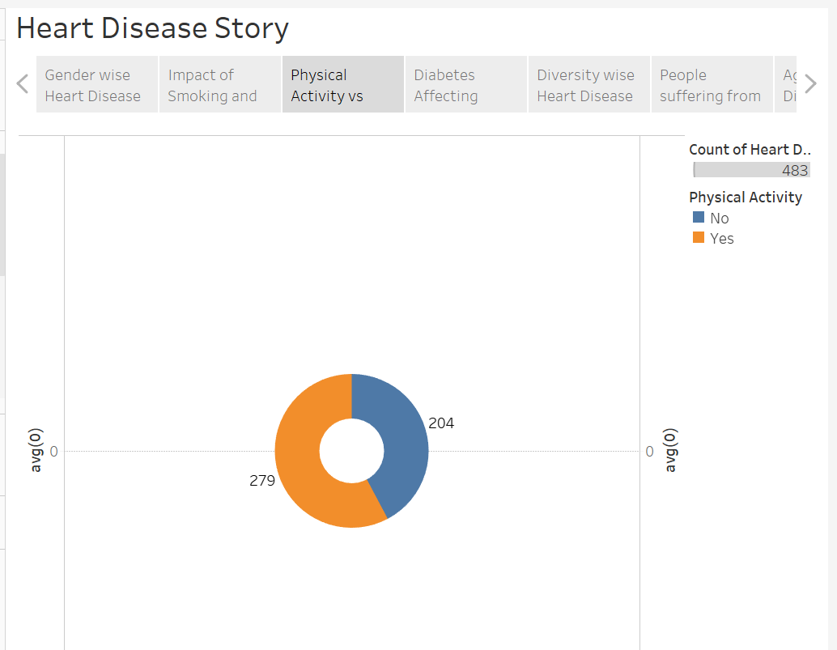

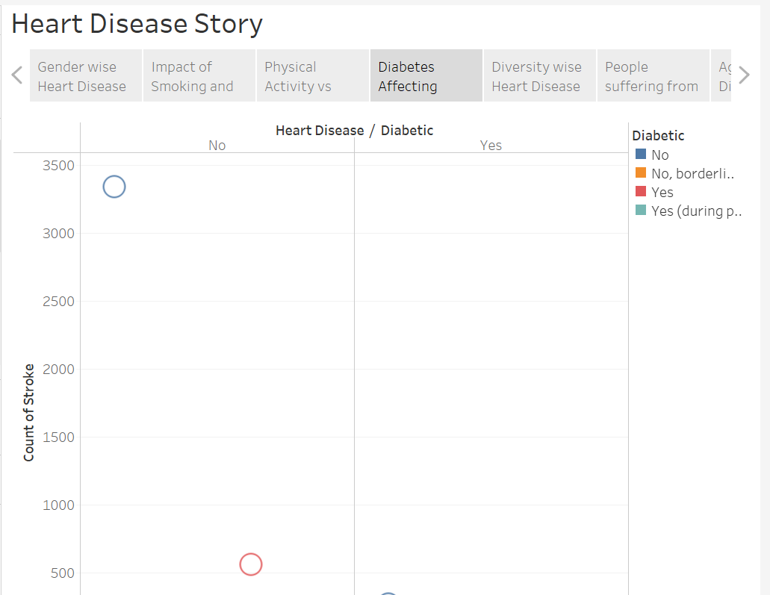

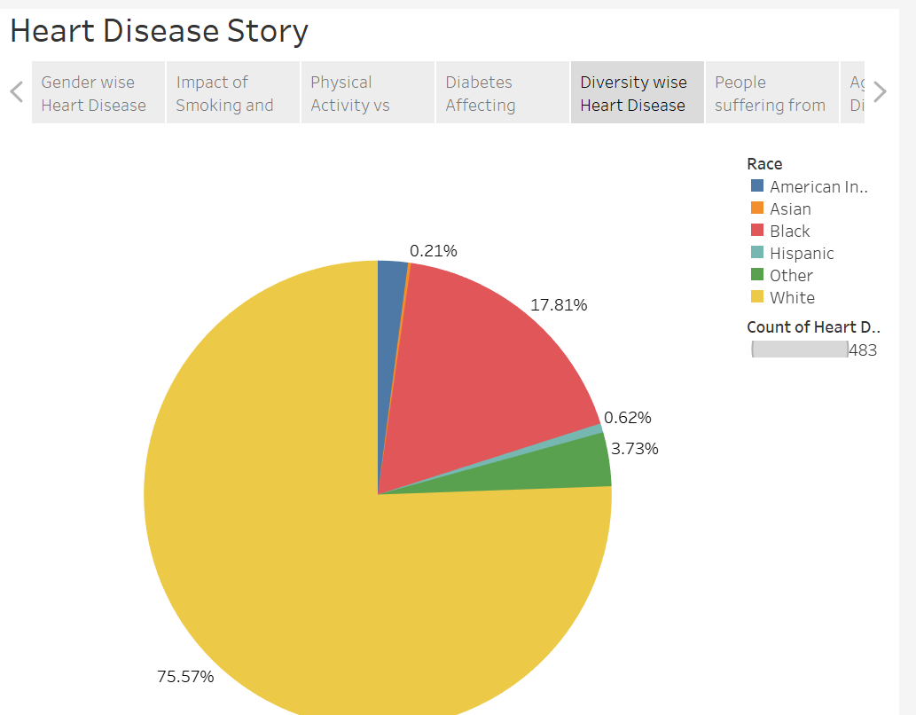

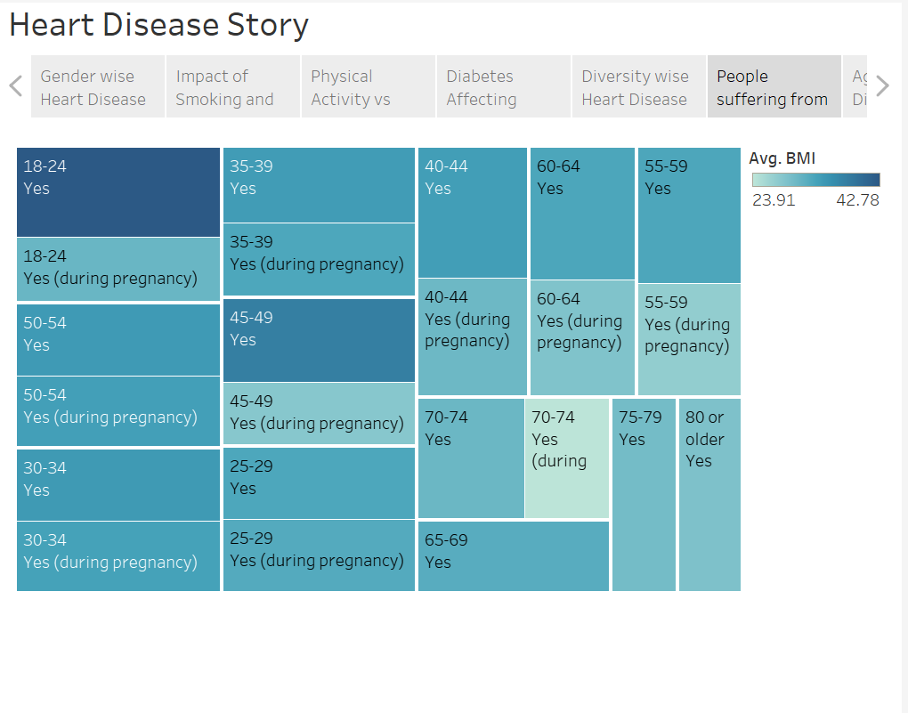

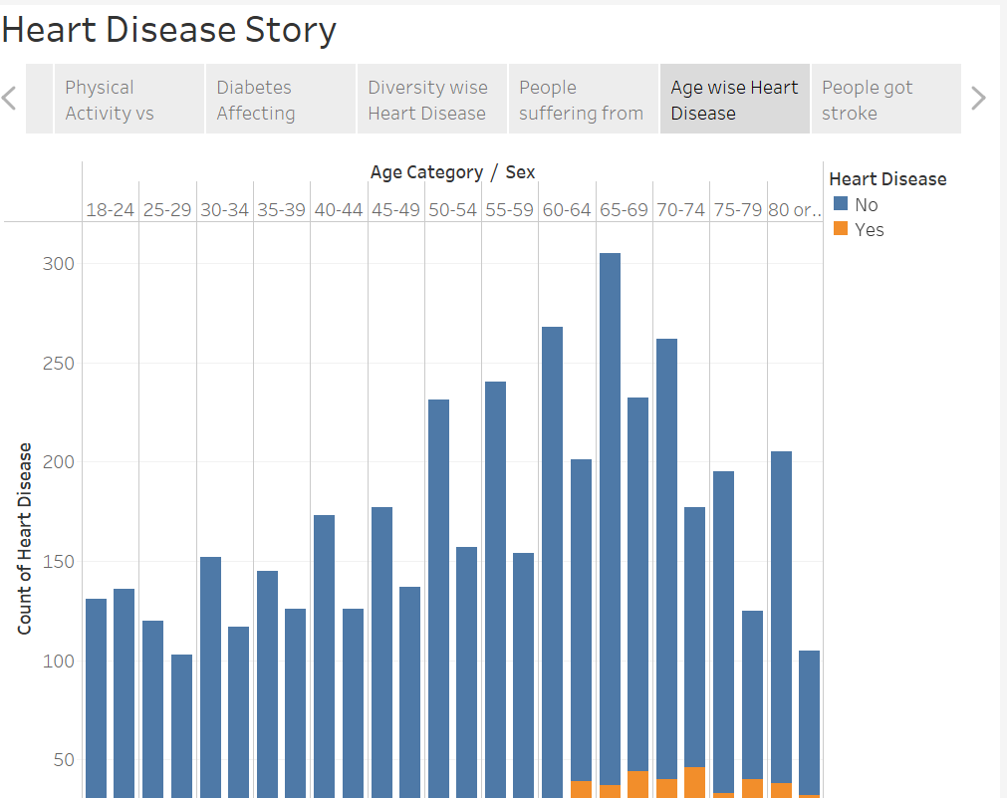

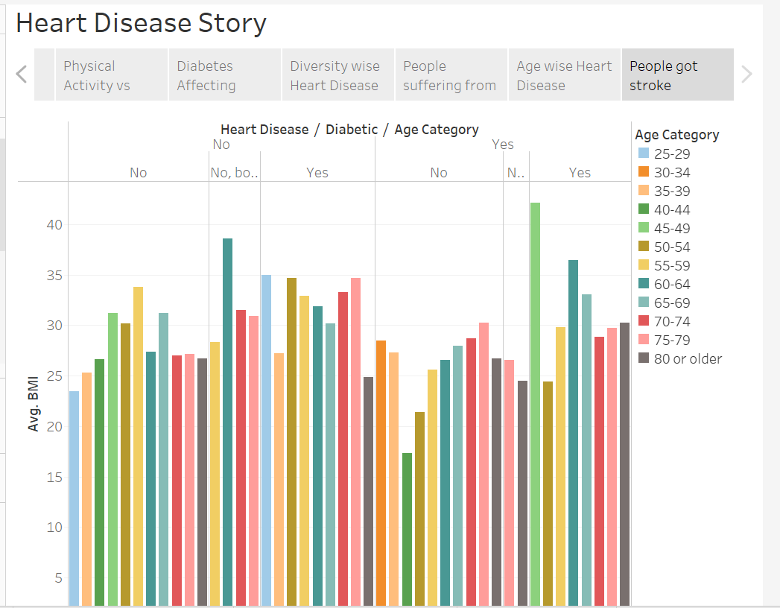

**Performance Testing**

**Amount of Data Rendered to DB:**

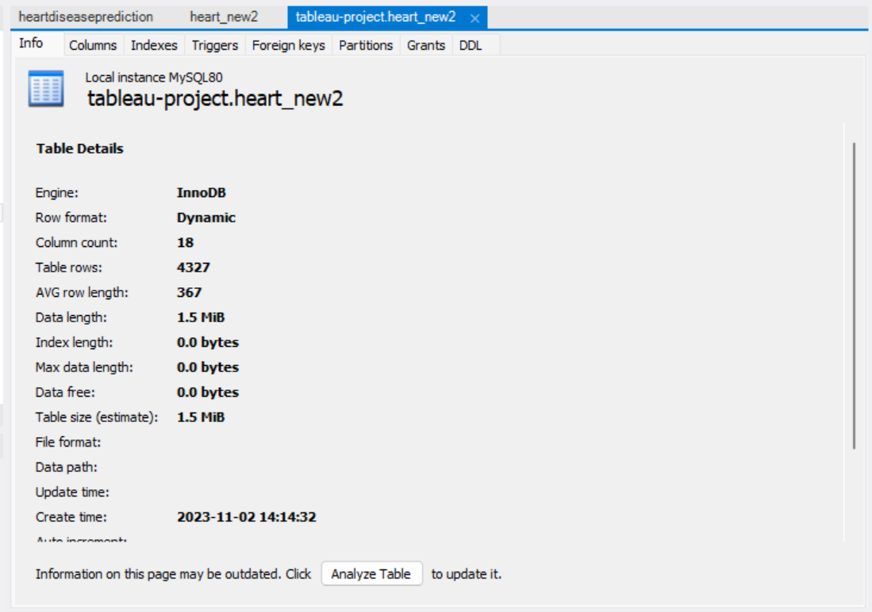

**Utilization of Data Filters:**

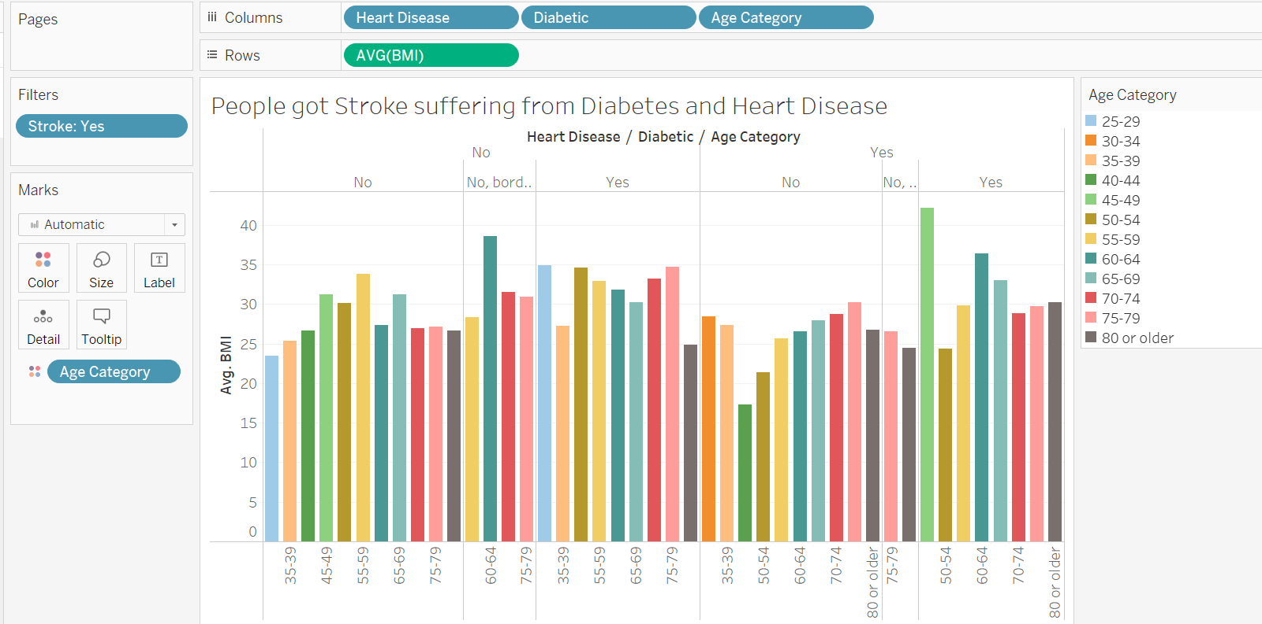

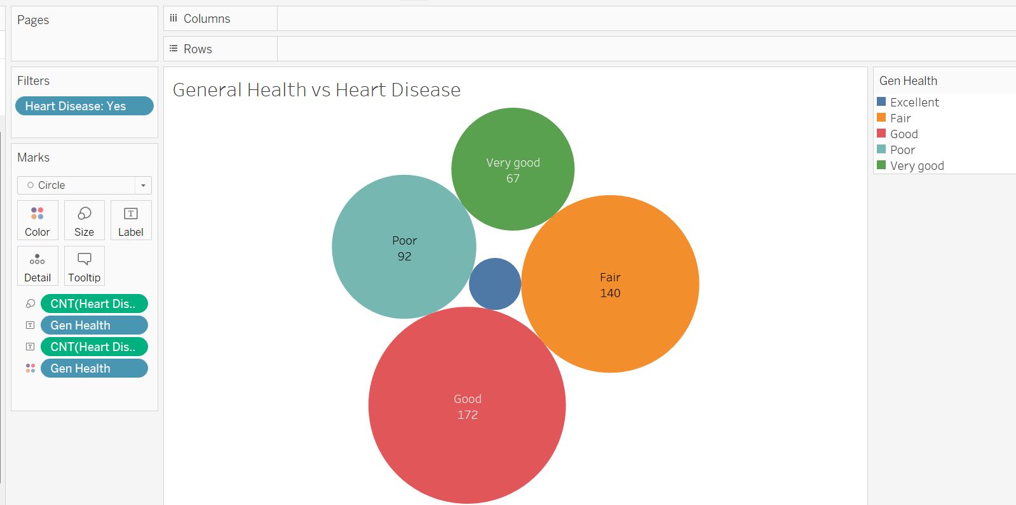

**No of Calculation Fields:** In this analysis we have not created any new column using calculation filed as data found in dataset was clean and sufficient for analysis.

**No of Visualizations/ Graphs:**

1. Gender wise Heart Disease

2. Age wise Heart Disease

3. People Suffering from Diabetic and Stroke

4. Impact of Smoking and alcohol drinking on heart disease

5. Other Diseases vs Stroke

6. Race wise Heart disease

7. General Health vs Heart Disease

8. Physical activity vs heart disease

9. Age and BMI vs Heart disease

10. People got stroke suffering from Diabetes and Heart disease

**Web Integration**

**Embed Dashboard and Story with Flask:**

